ANNA ADARSH COLLEGE FOR WOMEN.

DEPARTMENT OF PHYSICS.

TEAM MEMBER:

* SWETHA.M
* THARANI.R
* THLAGAVATHI.Y
* YUVARANJANI.B

***CHARTING THE COURSE OF ANALYSIS - START UP ANALYSIS***

**Introduction:**

The team start ups refer to a company in the first stage of operations. Start ups are founded by or more entrepreneurs who want to developed a product or service for which they believe there is demand. It allows entrepreneurs to identify the key areas that need improvement and make necessary changes early on. The start ups analysis is essential to the success of any start up bussiness. The concept is designed to reduce market risk by validating learning through the release of minimum valuable product.

Nowadays entrepreneurs turn their innovative thoughts ventures which provide solution to global problems. As a result a start ups ventures as a potential to grow into a enterprises that have a global effect. In a start up founders are the catalyst for a new goods service and business model to enter the market place. With the need to attract people into the business the founder relationship to the company and its stakeholders will alter. Even if you have an extraordinary entrepreneurial characteristics is difficult to achieve tremendous success alone thus putting together the proper team is critical to every successful firm.

**PURPOSES:**

The start up is the entrepreneurial venture in a early stages of operations typically created for resolving real life Ideation aims to build on the findings of the previous stages. It is when teams leverage their empathy for users and their design skills to solve the problems they’ve uncovered in the Define stage. During the Empathize stage, designers develop a sense of empathy for customers, allowing them to understand and contextualize their experiences, fears, and motivations Ideation is the third stage of the Design Thinking process — this is where the product team lays the groundwork for innovation and problem-solving. It’s preceded by the Empathize and Define stages that allow achieving a better understanding of the end-users and define product goals. A start up company is a newly formed business with particular momentum behind it based on perceived demand for its product or service. The intention of a start up is to grow rapidly as a result of offering something that addresses a particular market gap. Ideation aims to build on the findings of the previous stages.

PROBLEM DEFINIPNG AND DESIGNING THINKING

* EMPATHY MAP

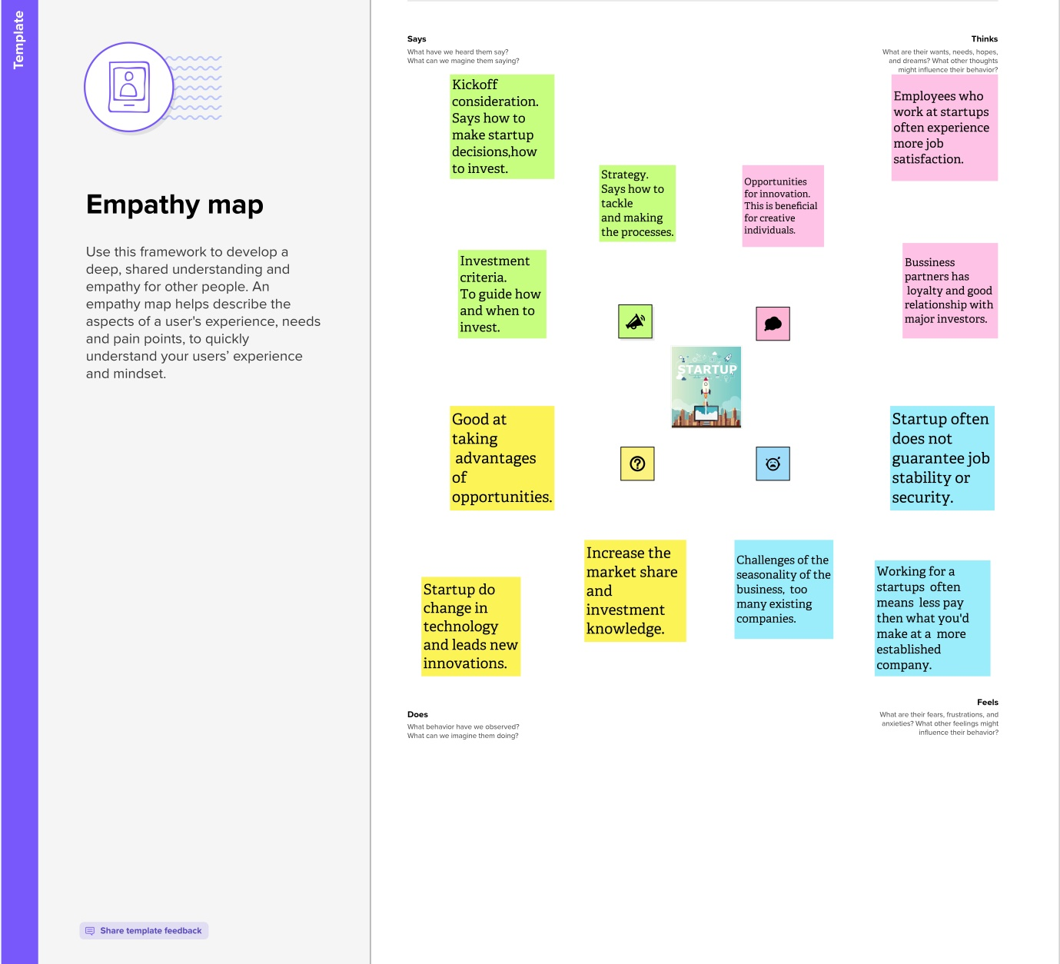

* IDEATION AND BRAINSTROMING MAP

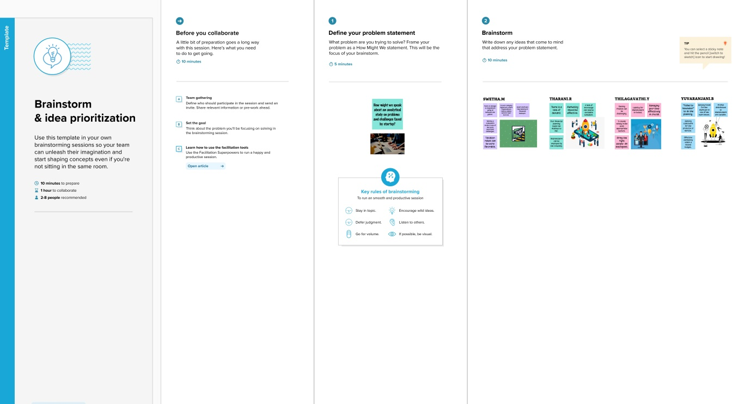

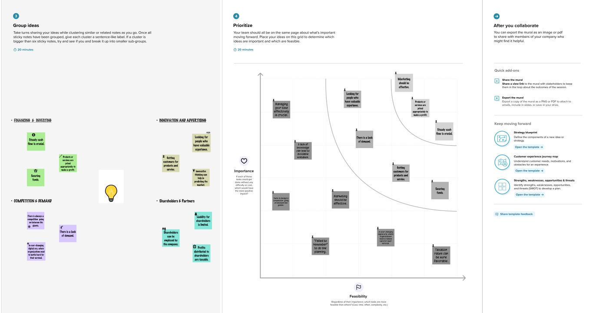

RESULT:

DASHBOARD

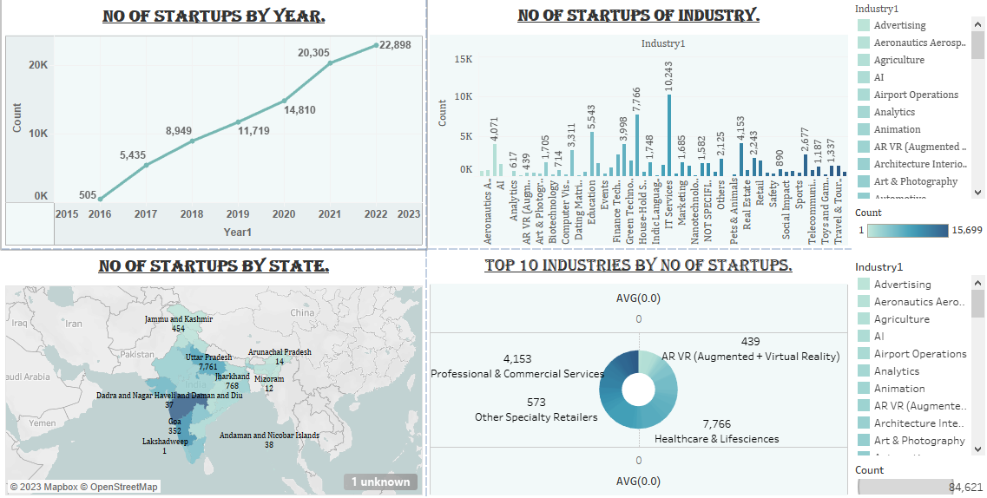

STORY

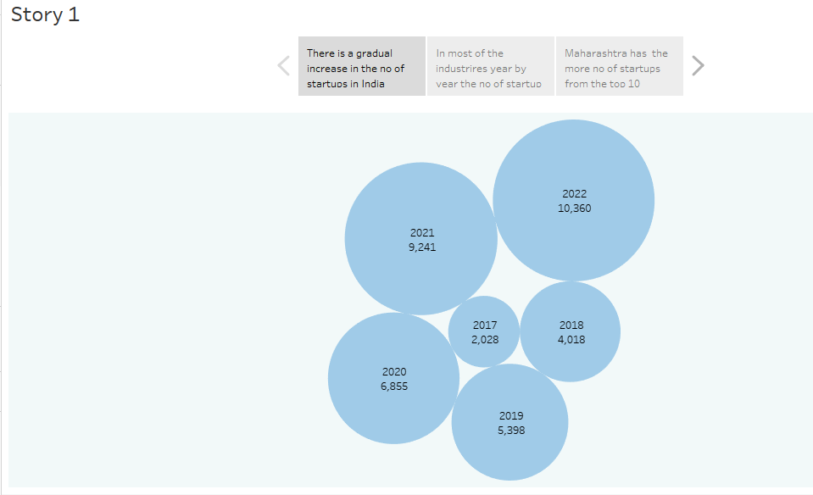

ADVANTAGES:

* Provides more learning opportunities

Often, a start up delegates more authority to employees than large corporations. This is because most start ups cannot recruit multiple employees with diverse responsibilities. Usually, they hire employees based on a specific skill set but may assign additional responsibilities to compensate for the extra work. This can be an advantage for new professionals who want to learn new things.

* Provides flexible schedule

Many start ups provide flexible work schedules and some even offer work from home. This is an excellent benefit for professionals who want to maintain a work-life balance. When companies provide a flexible work schedule, it increases work effectiveness because employees can focus on work without getting overwhelmed.

* Offers unique perks and benefits

Working in a start up differs from working in any other type of business. The experience employee gain at a start up differs from other companies. Some start ups may provide catered lunches or nap time to encourage employees to work productively. They provide unique perks and benefits to keep employees happy.

* Promotes innovation

A start up gives employees opportunities to show their expertise and abilities by contributing to their growth or success. Unlike large corporations that follow a streamlined process, employees working in a start up can pitch their ideas directly to the top management. This work environment is ideal for more creative people who want to share their new ideas.

DISADVANTAGES

1. Risk

Most start ups fail within their first year of operations, so the risk of failure is high. Working under such high risk can blur a start up’s strategic vision. So they either fail to seize market opportunities or overestimate their sales projections. High risk also hinders a start up’s ability to attract experienced and competent staff.

2. Compensation

It takes blood, sweat, and tears to build a company, and long working hours are the norm for start ups. The rewards might be low since it takes time to generate revenue and make profits. Some start ups give up since it’s demotivating to work without proper compensation.

3. Market Access

Many customers prefer a business that they have worked with over a new start up. Besides it is more expensive to acquire new customers than to retain old ones. Without a customer base, understanding market needs also becomes a real struggle. All these factors combined increase the cost of business development for start ups.

4. Team Composition

Some start ups are born out of desperation since the founder could not find or hold on to a job. Such founders often struggle to build a team that the business needs to succeed. A successful start up requires founders/co-directors with complementary personalities and competencies. Even then disagreements can creep in when the going gets tough.

5. Resources

Growth hacking, cloud computing, and venture capitalism allow start ups to gain market entry. Most start ups operate on a shoestring budget, against competitors that are well-resourced. It gives the competitors an edge in product development, sales, and marketing. They use that edge to push start ups out of the market when they become a threat.

APPLICATION

* Small business start ups.
* Buyable start ups.
* Scalable start ups.
* Offshoot start ups.
* Social start ups.

CONCLUSION

From the given data about the number of start ups, we can understand that there is a gradual increase in the start up of industries year by year.

FUTURE SCOPE

* Start ups continue to bring innovation and disruption in multiple industries, including Space Tech, Fem Tech, Health Tech, and Fin Tech. The stage is set for India to realise its vision of becoming a USD5 trillion economy and global powerhouse by 2024-25.
* Start ups are small companies but they play a big role in the economic process. They create more jobs which insinuates more employment, and more employment means an improved economy.